CS 255 System Design Document Template
Shaveze McDonald
This template lays out all the different sections that you need to complete for Project Two. Each section has guidance to prompt your thinking. You will need to continually reference the interview transcript as you work to make sure that you are addressing your client’s needs. There is no required length for the final document. Instead the goal is to complete each section based on what your client’s needs are. Remove this note when you are finished, and replace all bracketed text with the relevant information.

UML Diagrams

UML Use Case Diagram
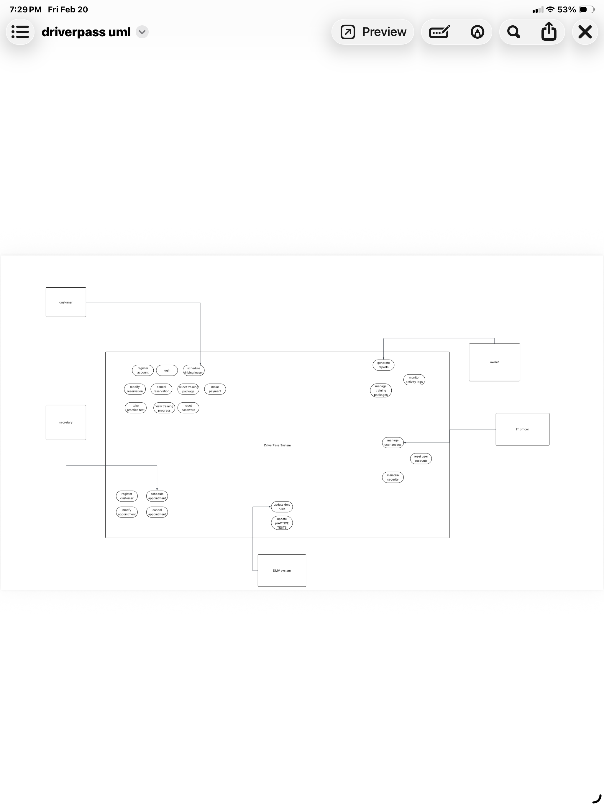

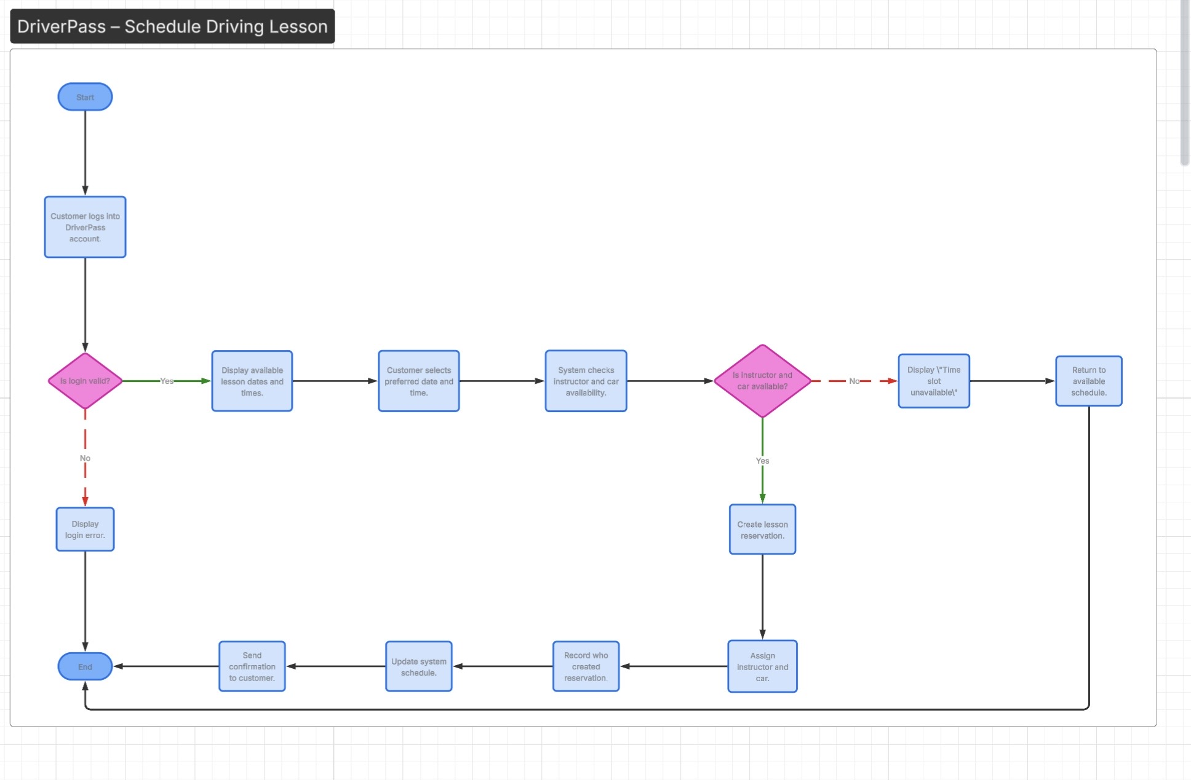
UML Activity Diagrams

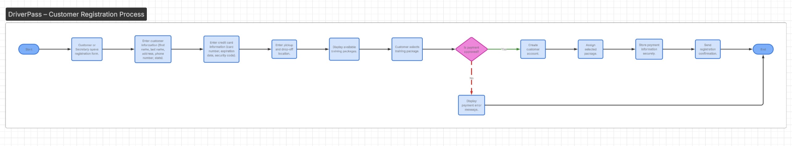
UML Sequence Diagram
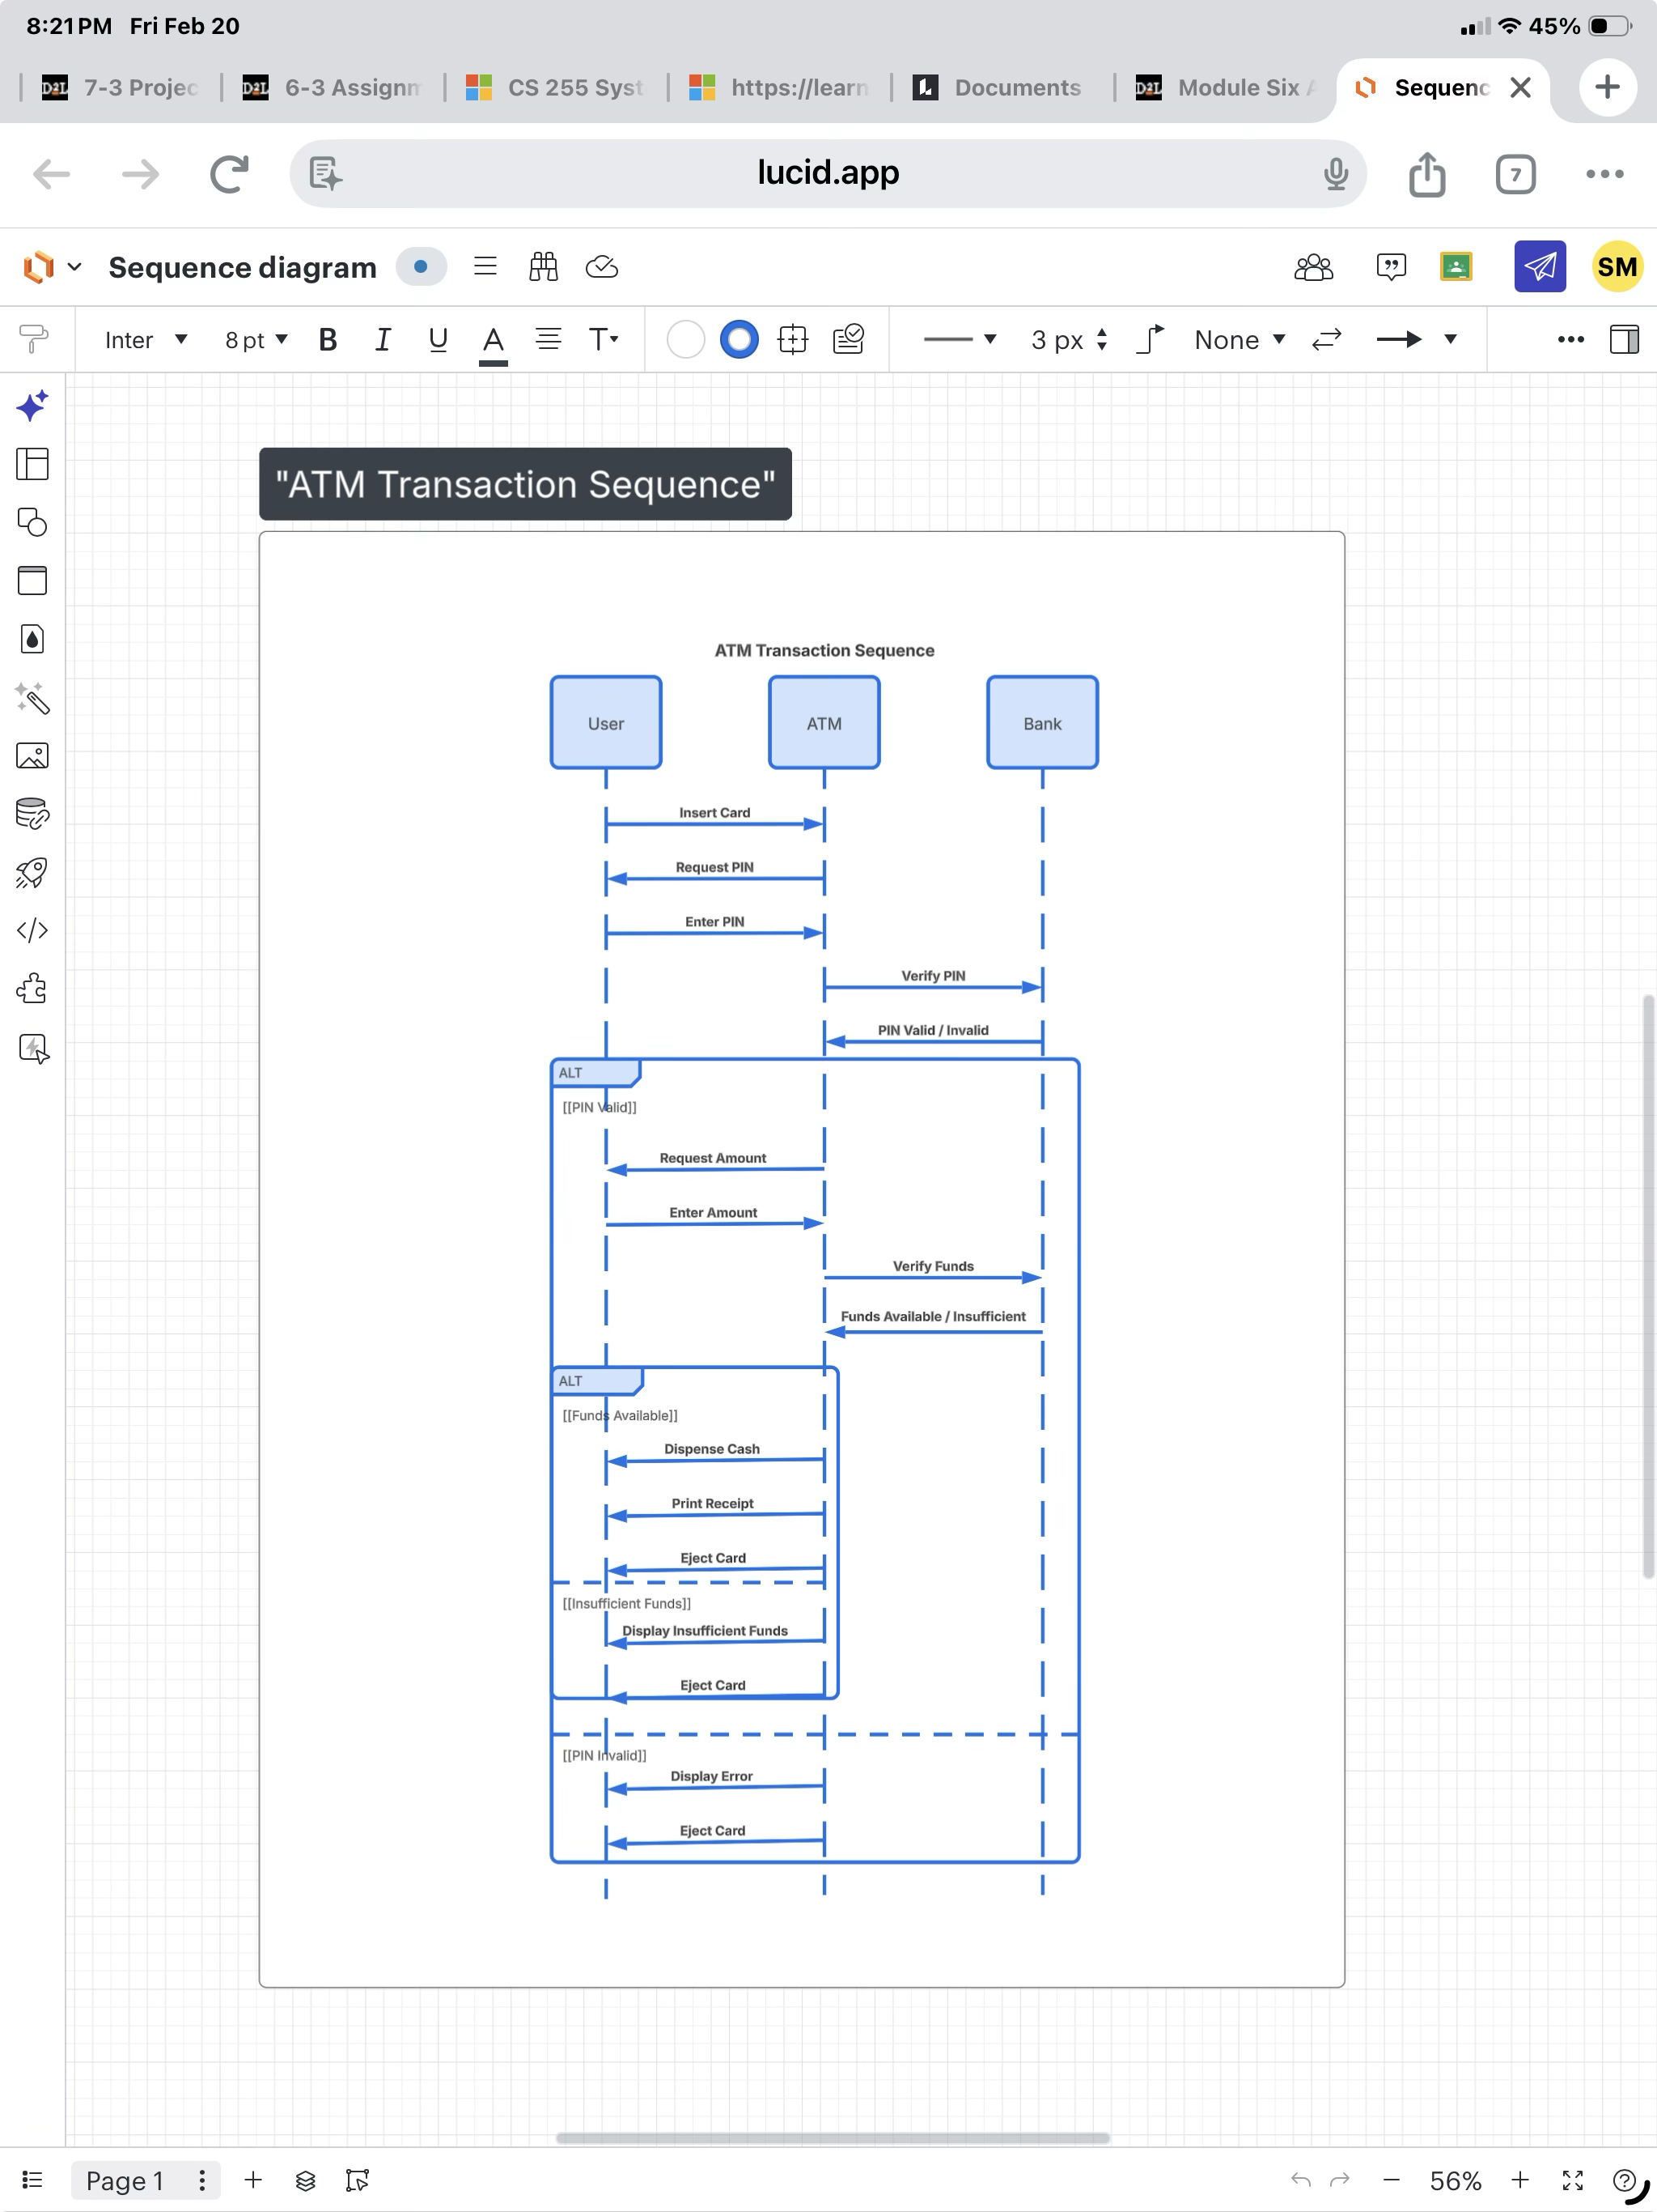

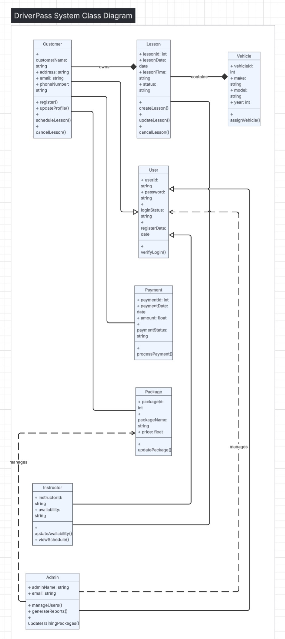
UML Class Diagram
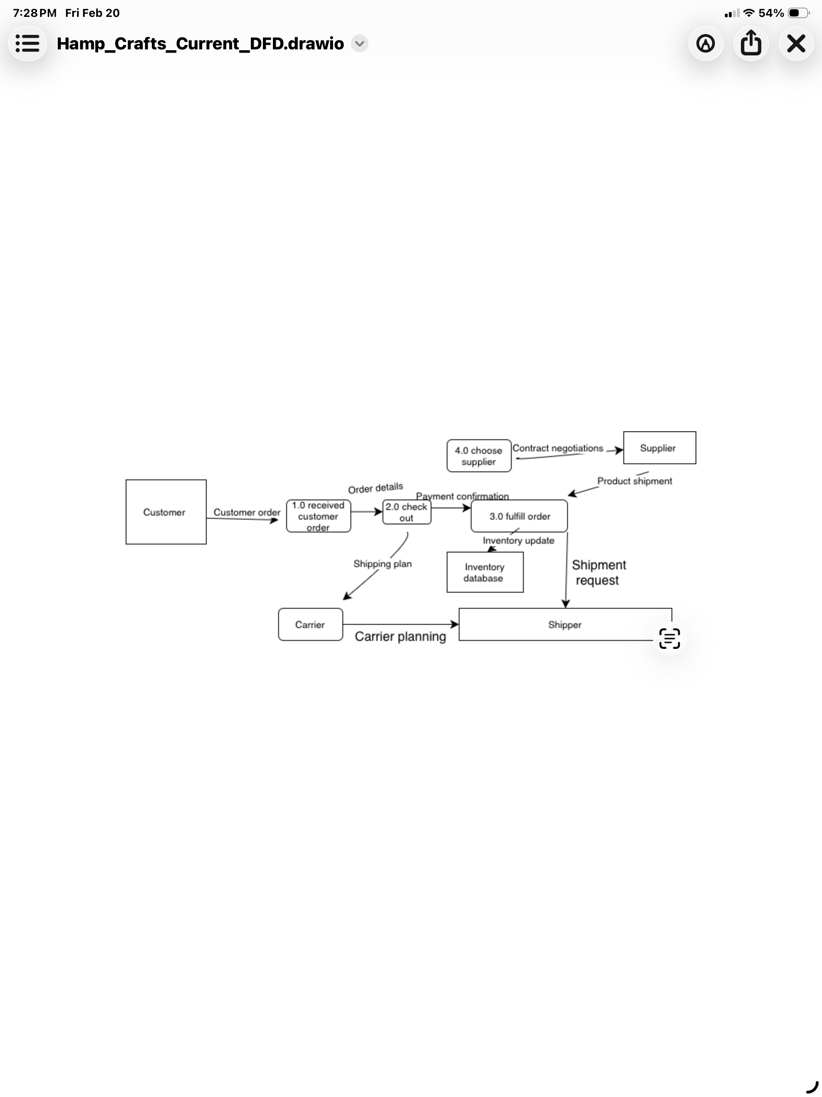

Technical Requirements
The DriverPass system will be a cloud-based, web-accessible application designed to support customer scheduling, online learning, and administrative management. The following technical requirements define the hardware, software, security, and infrastructure needed to support the system.

Hardware Requirements
The system must be accessible from standard desktop computers, laptops, tablets, and smartphones with internet connectivity. No specialized hardware is required for customers. Office staff may require printers for generating reports and confirmation documents.

Software Requirements
The system will operate as a web-based application accessible through modern web browsers such as Chrome, Edge, Safari, or Firefox. The application will run on a cloud-hosted server environment to allow secure, remote access from any location. A relational database management system will be used to store user accounts, lesson reservations, instructor schedules, vehicles, packages, and payment records.
The system must support online scheduling functionality, secure login authentication, password reset capability, and role-based access control for different types of users including customers, instructors, secretaries, administrators, and IT personnel.

Database and Data Management Requirements
The system must maintain structured database tables for:
- Users and roles
- Customers
- Instructors
- Vehicles
- Lesson reservations
- Training packages
- Payments
- Activity logs and audit records
The system must track who creates, modifies, or cancels reservations to maintain accountability and generate activity reports.

Security Requirements
The system must implement secure authentication and encrypted communication using HTTPS. Role-based access control must restrict system features according to user type. Sensitive information such as payment details must be securely stored and protected. The IT officer must have the ability to reset passwords and disable user accounts when necessary.

Integration and Infrastructure Requirements
The system must integrate with DMV updates to ensure that practice tests and driving regulations remain current. The system must support notifications to inform administrators of DMV updates. Cloud hosting must provide backup, reliability, and scalability to support business growth.

